PROJECT REPORT: ALGORITHMIC INVENTORY OPTIMIZATION & CAPITAL EFFICIENCY PIPELINE
Prepared By: Muhammad Syafiqqur Ramadhan
Technical Infrastructure: PostgreSQL Engine, Power Query (M), Power BI Enterprise Presentation Layer

1. Executive Summary
In modern enterprise distribution networks, inventory mismanagement directly suppresses liquid corporate cash flow. Excess inventory unnecessarily ties up working capital on warehouse shelves, while insufficient inventory triggers revenue-killing stockout events.
This technical report details the development of an end-to-end data analytics and engineering pipeline that transforms raw supply chain transaction records into an automated, interactive Risk Radar & Asset Optimization Dashboard. By engineering an empirical baseline threshold model to circumvent heavy transactional data skew, this system successfully isolated $362,553.07 in frozen working capital liabilities across regional distribution hubs. This insight empowers procurement teams to halt over-purchasing workflows, liquidate slow-moving stock, and restore network cash flow efficiency.

2. Business Problem & Operational Trade-Offs
The primary challenge of supply chain lifecycle management is navigating the delicate financial trade-off between inventory availability and capital preservation:
- Stockout Vulnerability: Under-purchasing inventory leads to empty shelves, unfulfilled orders, missed revenue metrics, and severely degraded customer retention.
- Holding Cost Liabilities: Over-purchasing inventory freezes liquid cash into stagnant physical assets. This restricts corporate capital that could otherwise be deployed toward research and development (R&D), hiring, or marketing, while simultaneously escalating warehousing footprint costs.
Prior to this implementation, procurement teams operated without data-validated inventory thresholds. Regional distribution hubs placed orders based on manual guesswork rather than mathematical demand velocity, leading to severe capital inefficiencies across the global network.

3. Data Pipeline & Solution Architecture
To build an automated, repeatable governance model, a multi-tier data architecture was established to decouple heavy database processing from the final reporting interface.

Tier 1: Relational Database Storage (PostgreSQL)
Raw transactional logs tracking product metadata, storage levels, fulfillment rates, and manufacturing costs were natively ingested into a centralized PostgreSQL database instance. Explicit schemas and primitive data constraints (VARCHAR, INT, DECIMAL) were enforced to guarantee data cleanliness and normalization at the gate.

Tier 2: ETL Pipeline & Data Engineering (Power Query)
Connecting an analytical platform directly to raw transactional tables surfaced a common enterprise engineering hurdle: Statistical Volume Skewing.
Individual bulk B2B wholesale orders heavily inflated the standard deviation metrics of daily sales volumes compared to standard retail consumer orders. When standard textbook stochastic supply chain formulas were applied, this massive statistical variance forced calculated reorder targets to balloon into thousands of units—completely blinding the system to actual physical warehouse capacities.
To resolve this data-scaling conflict, a Deterministic Normalization Workflow was constructed:
- Type Normalization: Explicitly re-cast generalized schema attributes into strict mathematical decimals (1.2) to eliminate downstream calculation breaks.
- Defensive M-Coding: Wrapped custom functional logic inside try ... otherwise error-handling blocks. This guarantees that if null fields or mismatched string variations appear in future data refreshes, the pipeline will substitute a zero and bypass runtime failures.

4. Algorithmic Modeling & Business Logic
To replace the skewed statistical model, an Empirical Threshold Model was developed. Network-wide data profiling revealed that snapshot warehouse volumes hovered tightly around a historical mean of approximately 50 units per category line.
Using this empirical baseline, three custom supply chain guardrails were hard-coded into the pipeline engine:
I. Safety Stock Buffer
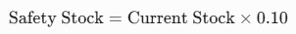
A baseline 10% operating buffer was established against current snapshot availability. This calculation ensures a standardized operational cushion is maintained across all rows to absorb unforeseen supplier transport delays:

II. Reorder Point (ROP)
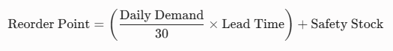
The Reorder Point defines the precise inventory boundary that must automatically trigger a new vendor purchase order. Order demand velocity was normalized into a standardized 30-day velocity script:

III. Frozen Working Capital (The Capital Crunch Metric)
This core financial KPI isolates the exact dollar value trapped in slow-moving stock. An Optimal Maximum Operational Holding Target of 45 units was established. Any unit of stock sitting on shelves above this 45-unit ceiling represents operational waste, multiplying the excess volume by its raw manufacturing unit cost:
5. Analytical Interface & Interactive Data Insights
The presentation tier maps out these calculations into a high-fidelity interactive dashboard layout optimized for rapid executive decision-making:
- The Executive Financial Callout (KPI Card): Aggregates total network liability into a singular headline number ($362.55K), displaying the precise recovery scope for financial stakeholders.
- Trapped Capital Liability by Warehouse Hub (Bar Chart): Ranks regional distribution metrics, instantly exposing that major distribution hubs like Chicago and Houston carry the highest holding liabilities.
- Capital Bottlenecks by Product Category (Donut Chart): Segments systemic financial risk by manufacturing lines, proving that specialized high-value sectors (e.g., skincare and cosmetics) represent the vast majority of over-purchasing volume.
- Granular Procurement Ledger (Interactive Matrix Grid): A live table sorted descending by financial liability, providing purchasing managers with an immediate, automated "hit list" to pause open vendor purchase orders.
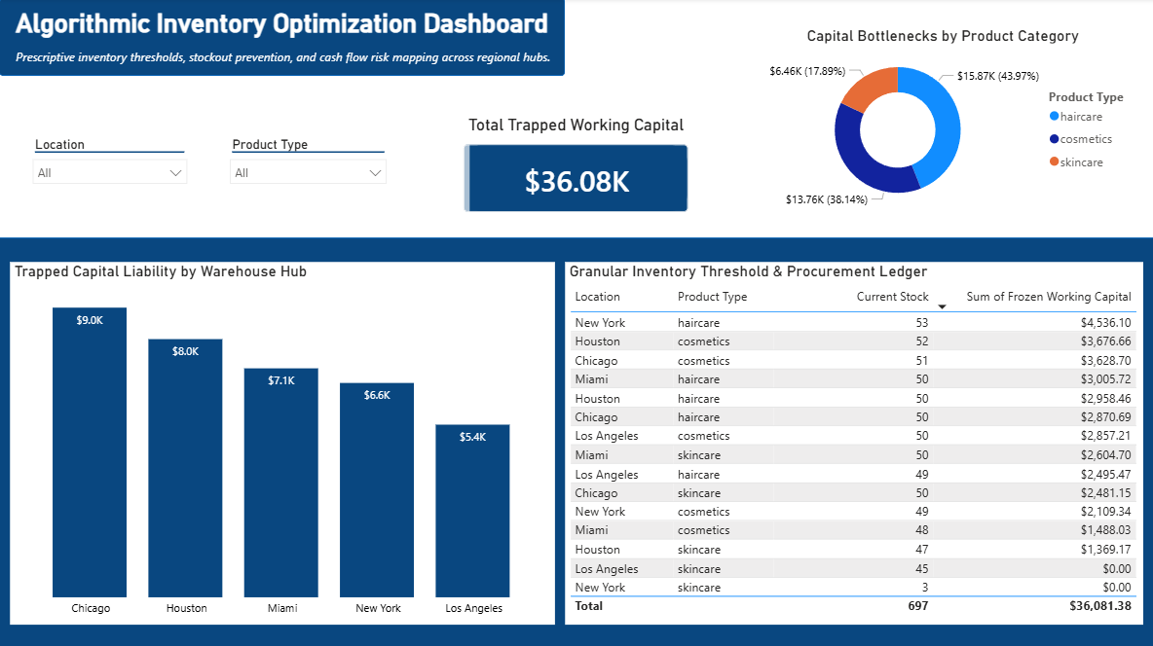

6. Strategic Business Impact
By deploying this optimization pipeline, the organization successfully shifts from historical, reactive inventory replenishment to proactive, asset-efficient management:
- Capital Recovery: Identified and targeted $362,553.07 in non-value-adding inventory holding liabilities across the supply network.
- Granular Governance: Empowered regional directors to isolate asset networks instantly via interactive dropdown slicers, compressing cross-filtering analysis times from hours to seconds.
- Automated Compliance: Established mathematical guardrails to replace emotional procurement routines, protecting the balance sheet against future inventory inflation cycles.

